**OPENSTACK**

**Introduction**

* Open Stack is open source software to build private and public clouds.
* Open stack is a open source software i.e. we never locked to a proprietary vendor, and modular design can integrate with legacy or third-party technologies to meet your business needs.
* To learn **open stack** the best way is go through **Devstack.**
* virtual machine is the preferred tool to install Devstack.

In virtual machine if any crash occur there is no two much of loose.

**Steps to install open stack in ubuntu**

**Step 1:** Initial steps

Here I am using 32bit ubuntu 12.04

1. Install Virtual Box

Create a new virtual machine and install 64-bit Ubuntu 12.04

1. Run the virtual machine
2. Open the console
3. Run an update command

$ Sudo apt-get update

1. Install github

$ Sudo apt-get install git

**Step2: Devstack setup**

1. Open the consol and execute bellow command

$ git clone <https://github.com/openstack-dev/devstack.git>

These command will install open stack and fetches the devstack repo to local machine.

1. Now we can find the devstack directory in console

$ cd devstack

1. $ ./stack.sh

Run this script to install open stack

* After it is done it will return a URL for horizon. Open that link in browser and we can access the Open Stack Dashboard.
* By default we get two usernames-admin and demo. The password will be the password we set for keystone which we can see in the local.config file in the devstack directory.
* Here we are done with the basic configuration for Open Stack.

**SNAPSHORT OF OPENSTACK INSTALLED IN MY COMPUTER**

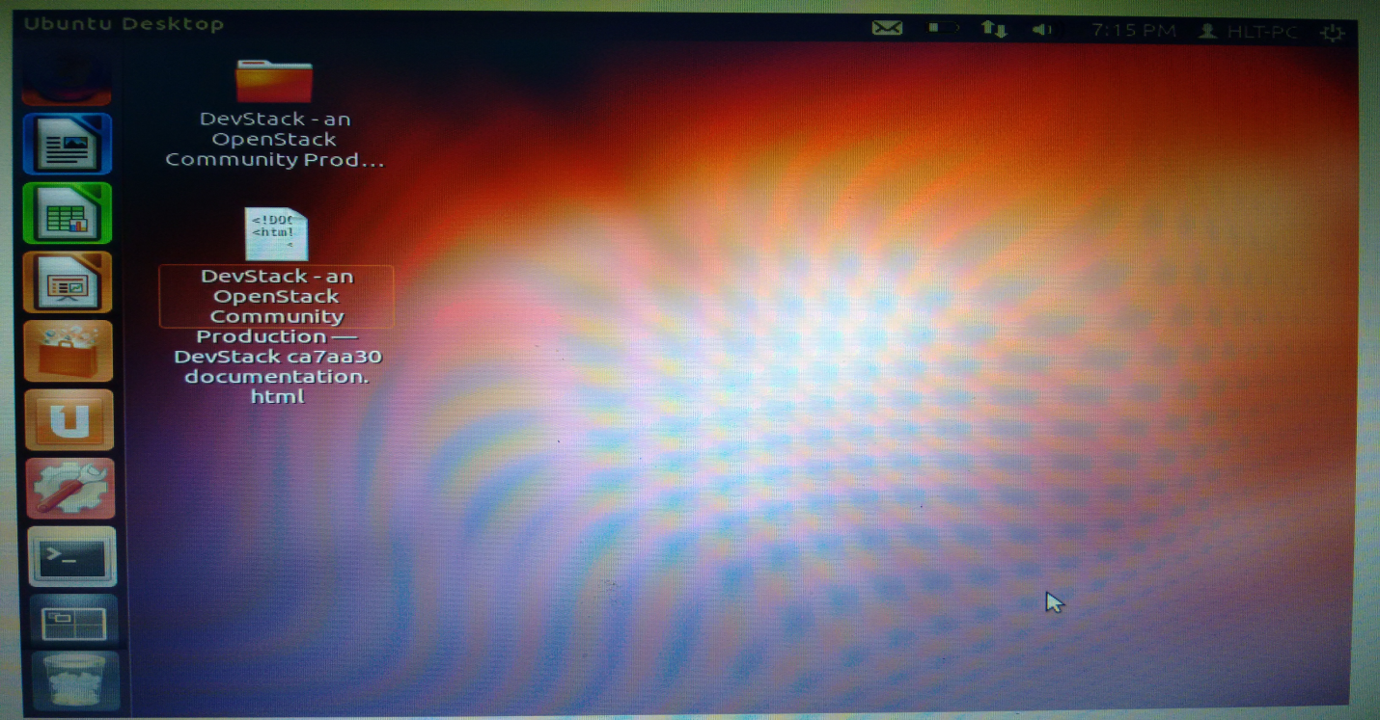

Openstack documentation folder and html document.

